Parallel and Distributed Computing

CSE4001

Fall Semester 2020-21

Lab Assignment 2

**ISHAAN OHRI**

**18BCE0265**

**Aim:**

Write a simple OpenMP program to demonstrate the use of ‘for’ clause.

* Print ‘n’ array elements
* Sum of n’ array elements
* Product of n’ array elements

Printing using a single thread

**Source Code:**

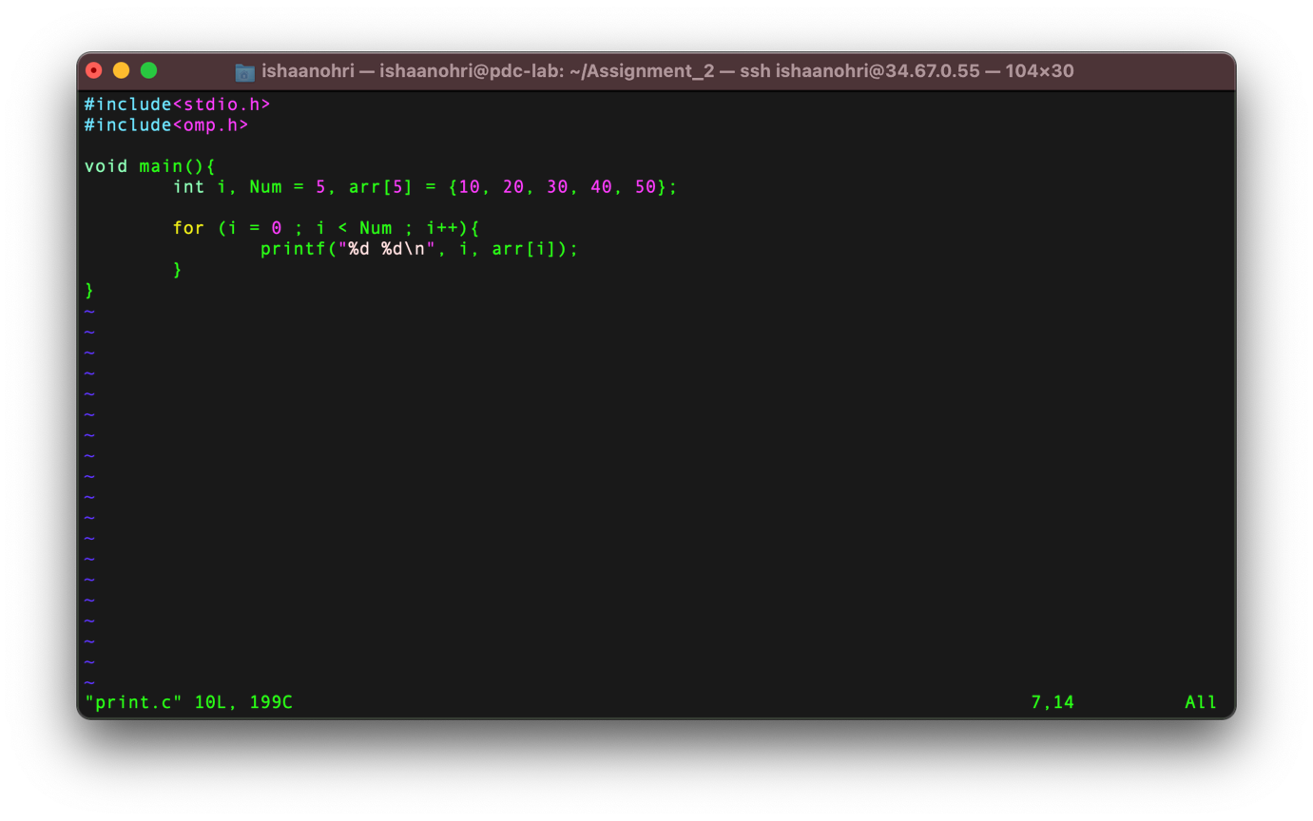

**Execution:**

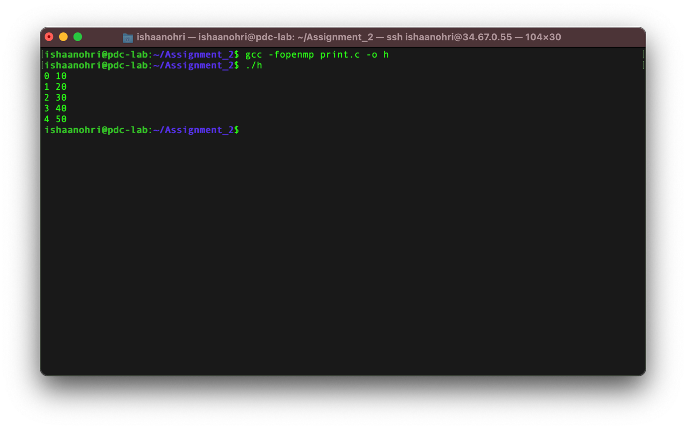

Printing using multiple threads

**Source Code:**

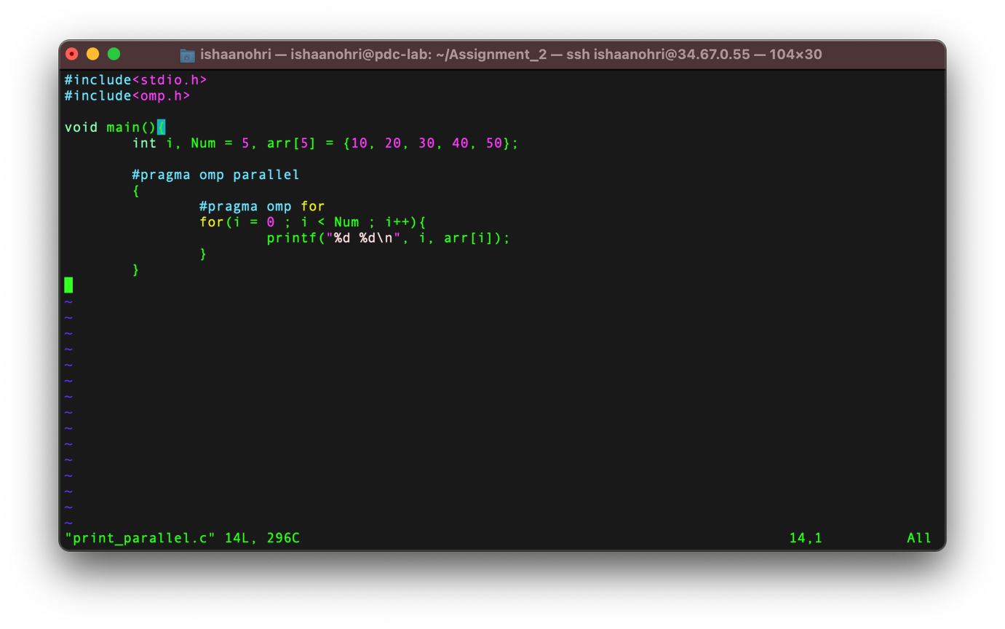

**Execution:**

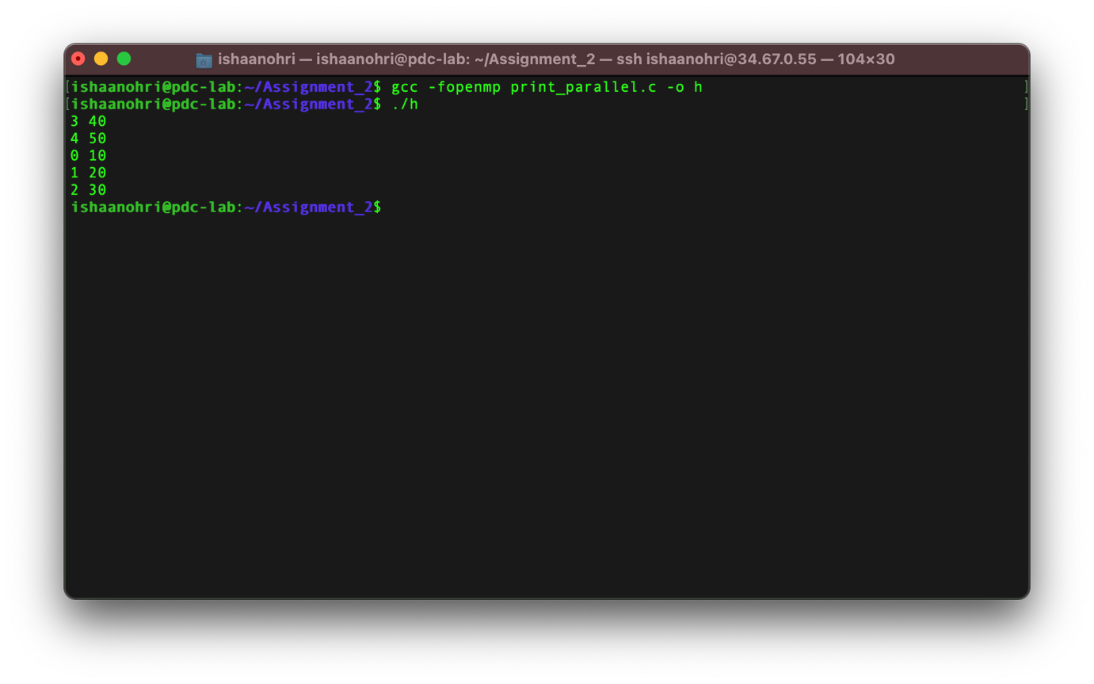

Sum using a single thread

**Source Code:**

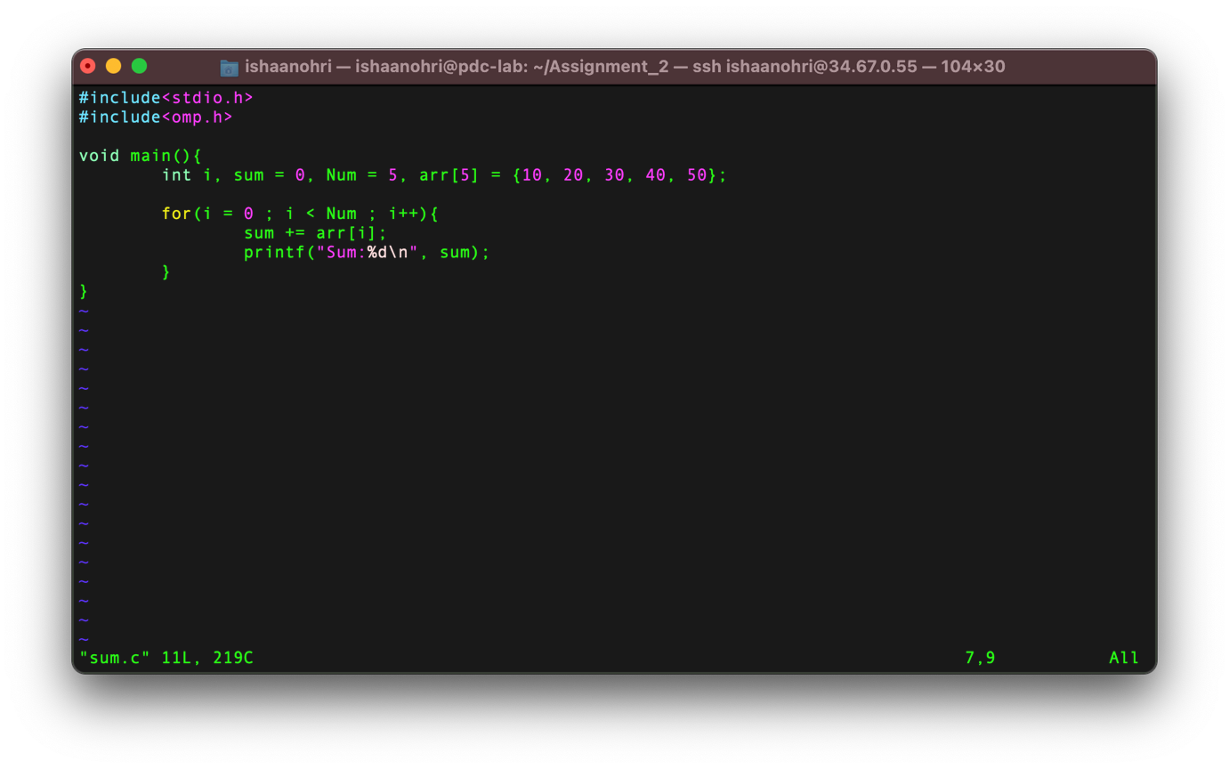

**Execution:**

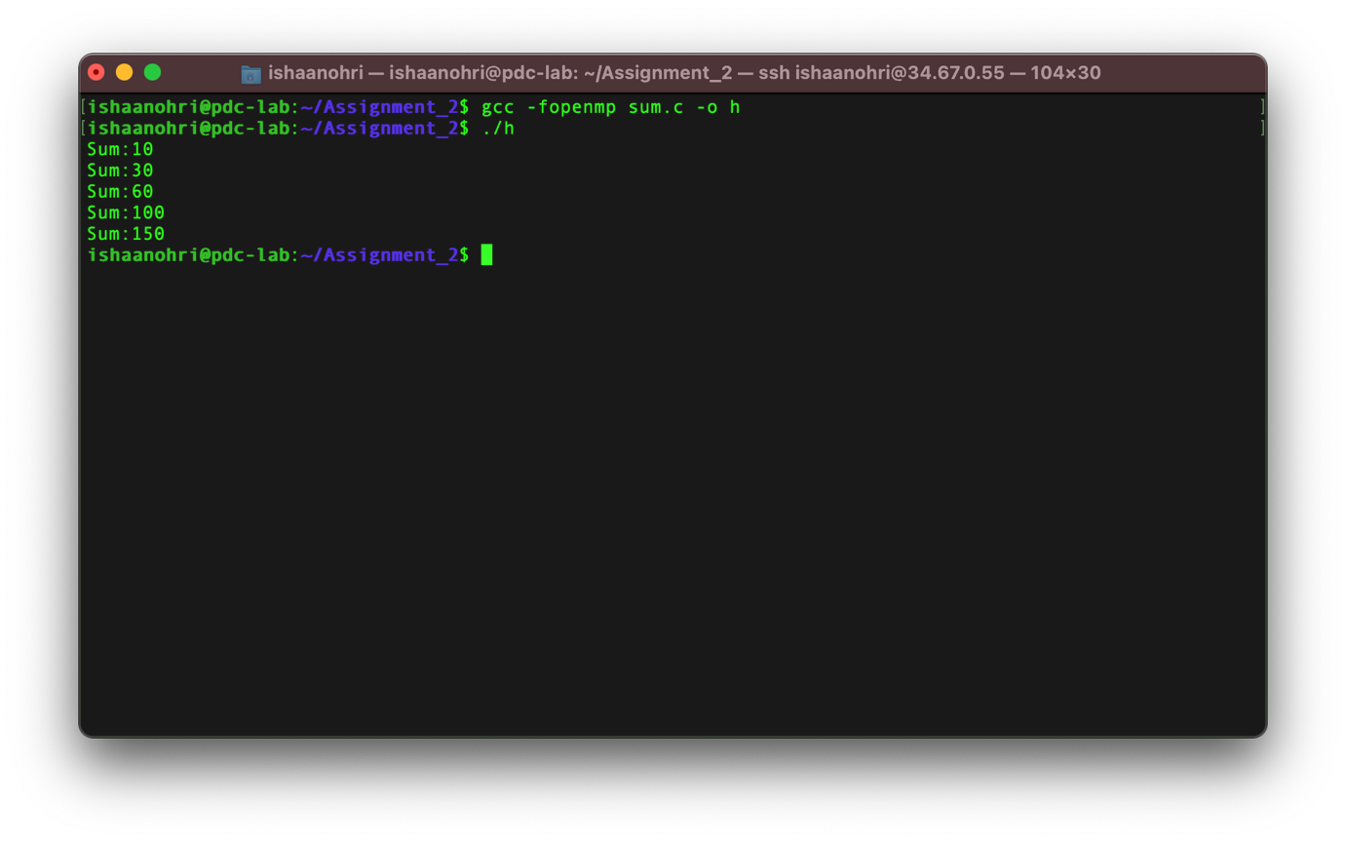

Sum using a multiple threads

**Source Code:**

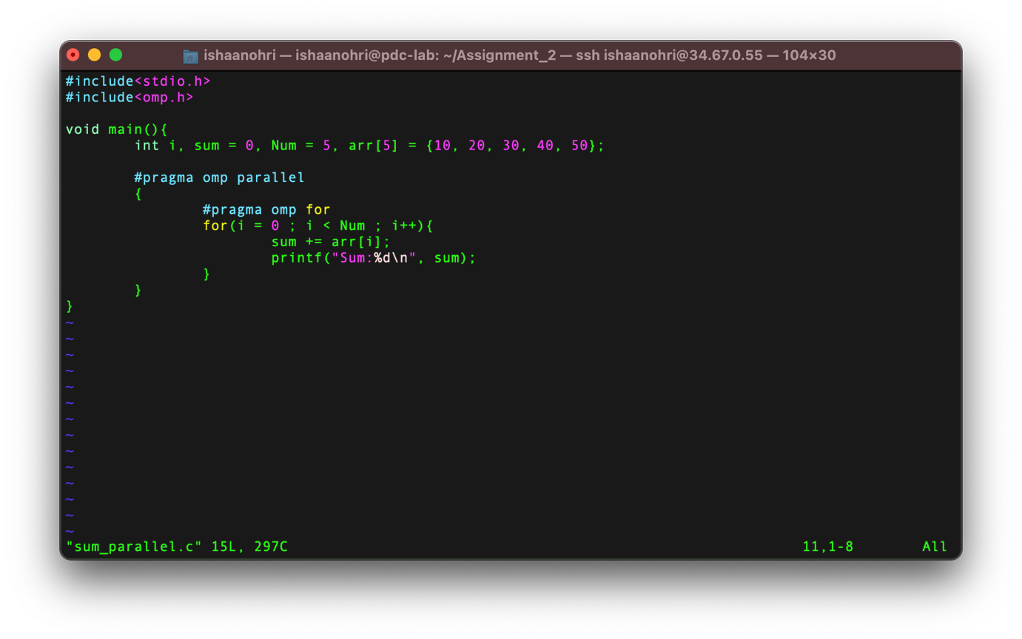

**Execution:**

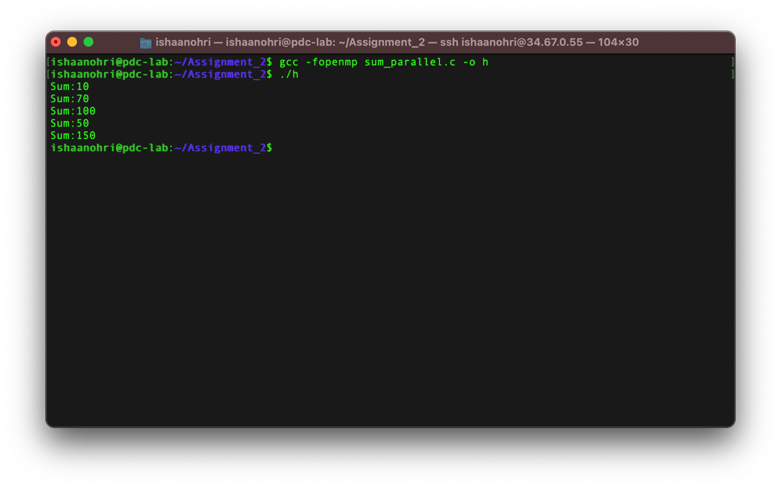

Product using a single thread

**Source Code:**

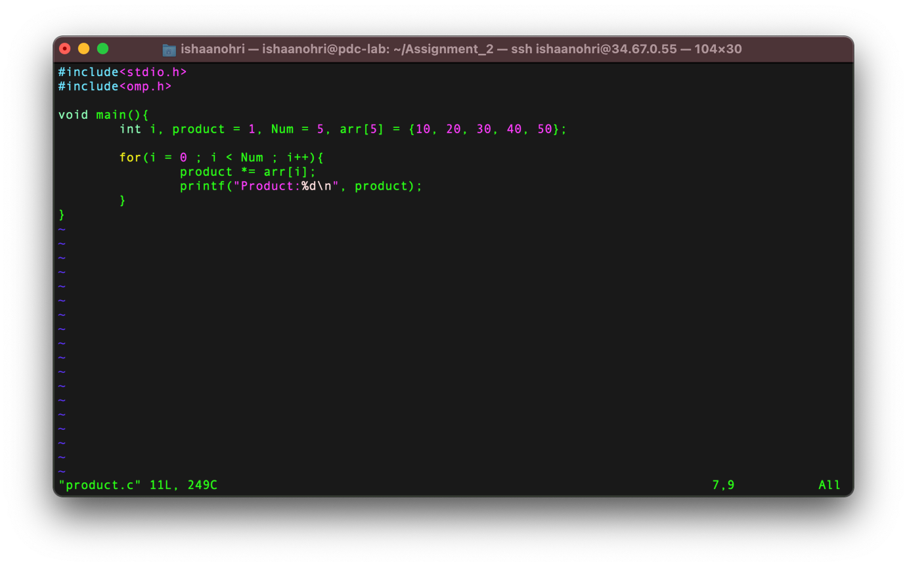

**Execution:**

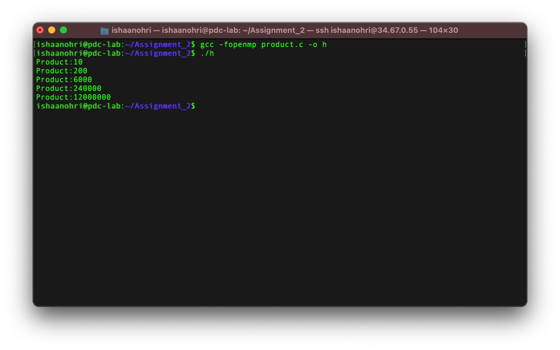

Product using a multiple threads

**Source Code:**

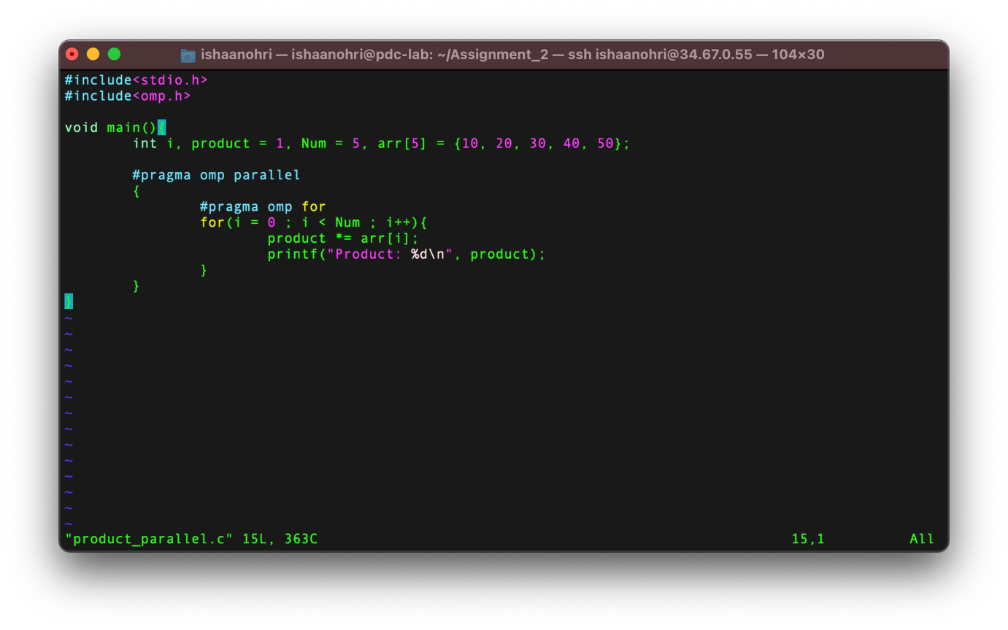

**Execution:**

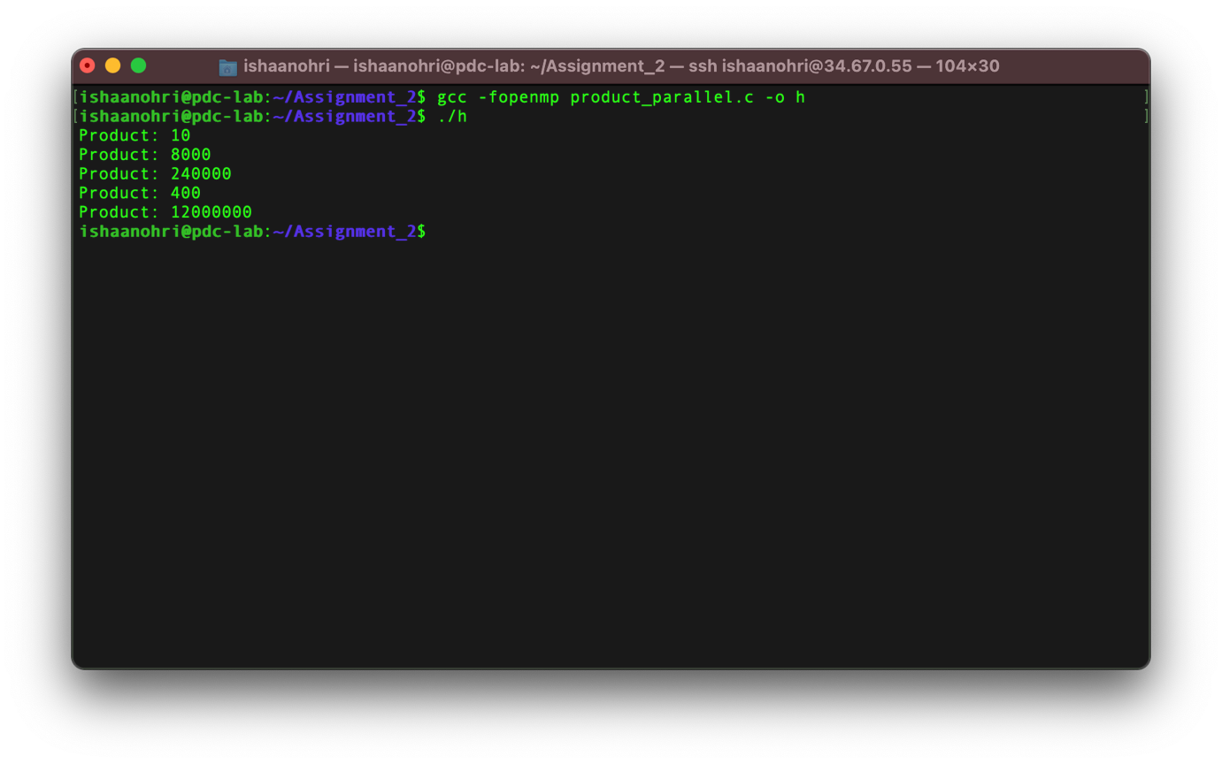

**Result:**

From this experiment I understood the usage of *for* clause using parallel pragma and arrays by printing of array elements, sum of array elements, and product of array elements. The above experiment was conducted and all results along with the source code have been attached above in the document. The experiment was assisted by Dr Deepak. I thank sir for his assistance.